Virtual Lab 4 – Impedance Matching and Smith Charts

# Youssef Samwel

# [yo800238@ucf.edu](mailto:yo800238@ucf.edu)

# EEL4436C Microwave Engineering

Section 0012

# Due Date 11/5/2023

# Quarter-Wavelength Transformer

1. (5 pts) Plot the S-parameters for the structure without the quarter-wavelength transformer. (You must run a sweep to plot the S-parameters)

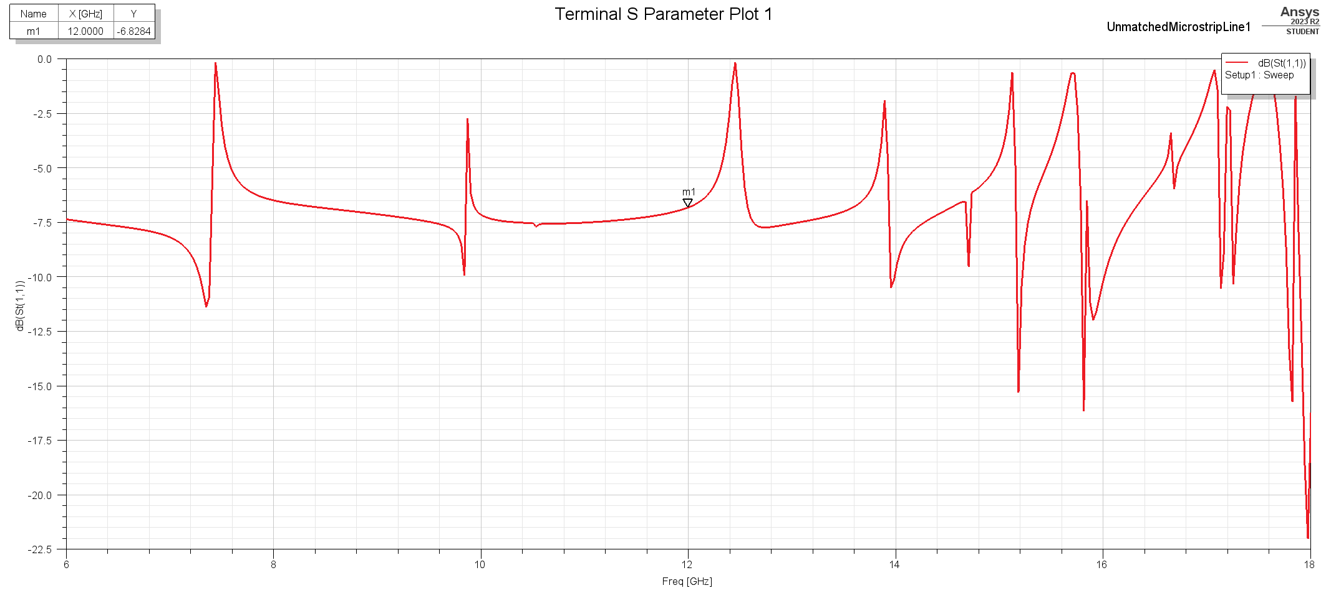

S11 of Unmatched Quarter-Wavelength Transformer

1. (10 pts) List the dimensions of your quarter-wavelength transformer. Show a screen capture of the final structure with the quarter-wavelength transformer.

The final dimension for the matching transfer is width = 4.88 mm and length = 3.98 mm.

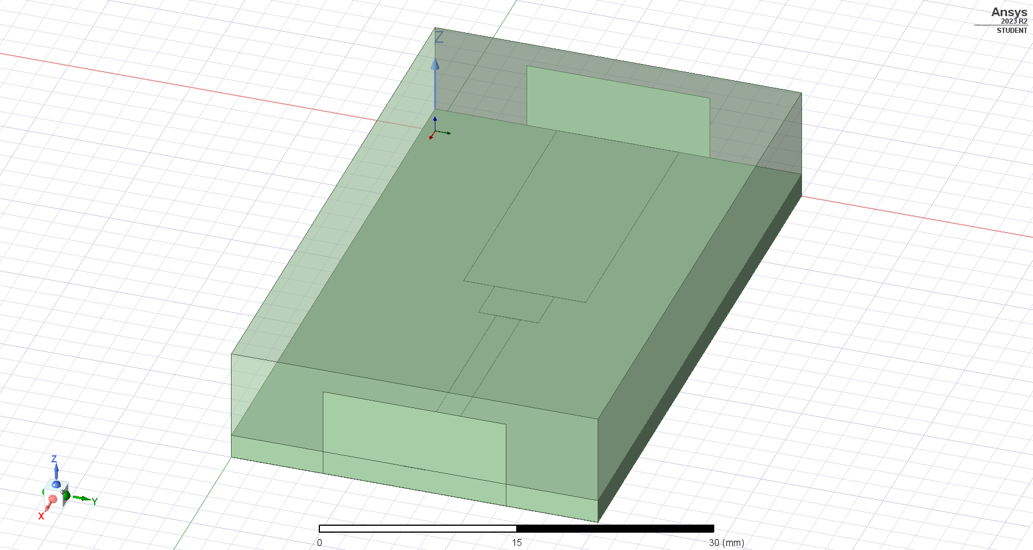

Structure of Matched Quarter-Wavelength Transformer

1. (10 pts) Plot the S-parameter for the structure with the quarter-wavelength transformer.

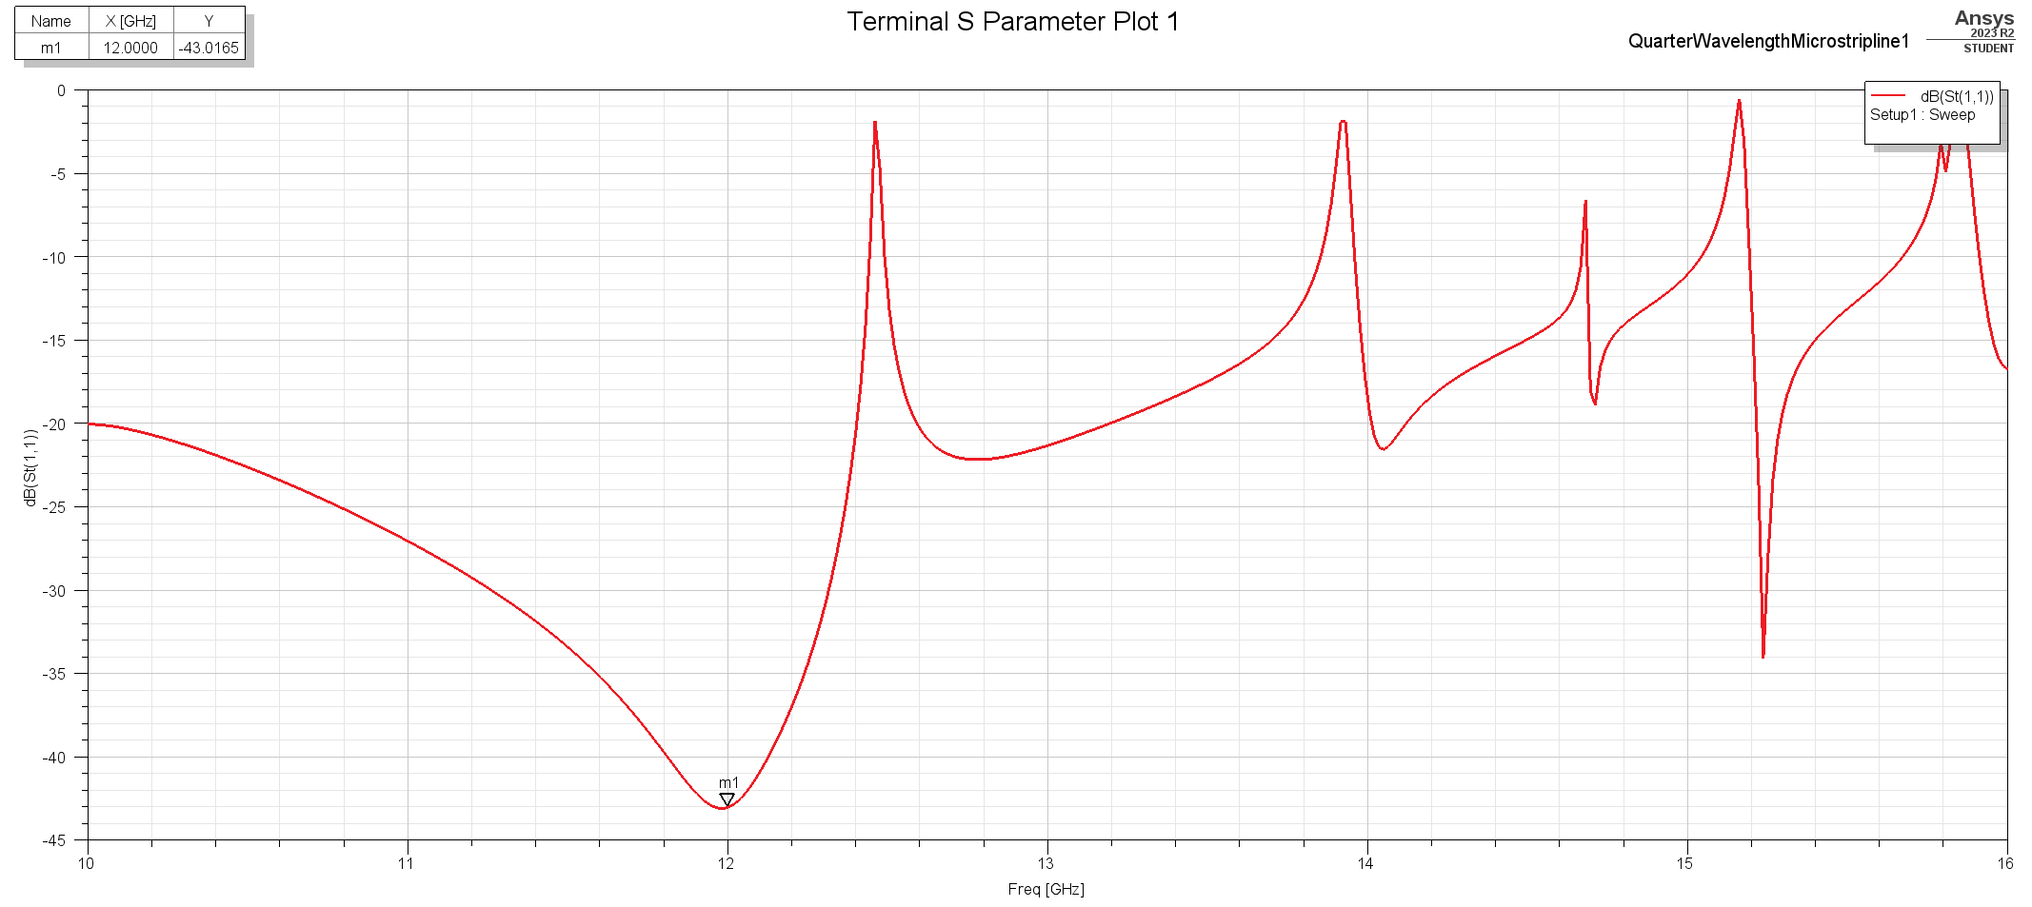

S11 of Matched Quarter-Wavelength Transformer

1. (5 pts) Does the best matching occur at 12 GHz? If not, what is the reason?

The original matching using the computed values occurred around 10-11 GHz this was because of estimation error from the microstrip line equations in the Pozar book. The benefit of those equations is that it provides an answer that is close to the real solution that only requires minor modifications.

1. (5 pts) What is the reflection coefficient at 12 GHz? What is the SWR at 12 GHz?

The reflection coefficient at 12 GHz is -43.0156 dB or 0.0071. The SWR at 12 GHz is,

$$SWR=\frac{1+|Γ|}{1-|Γ|}≈1.01$$

1. (5 pts) You might see a peak in S11 within the matching bandwidth which is unexpected. This is called box resonance. How do you remove it by explaining? (10 pts) Prove your method by doing another HFSS simulation.

To remove the spikes in the simulation I tried several boundary conditions and the most effective boundary conditions was the Radiation condition which smoothed the harsh peaks in the S11 plot. The radiation boundary conditions reduces the amount of energy the box absorbs at certain frequencies.

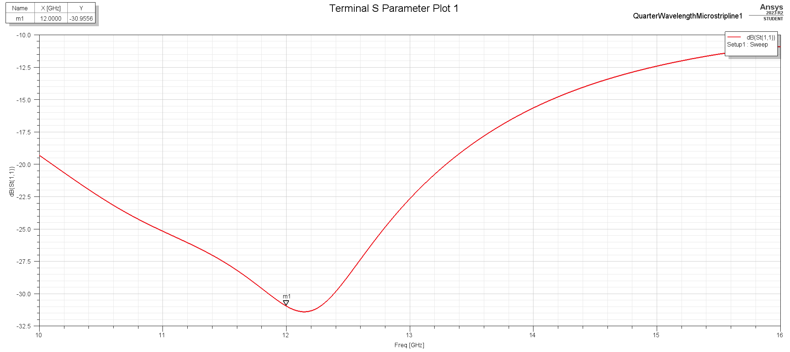

S11 Plot with Radiation Boundary Condition

1. (5 pts) Does the quarter-wave transformer work in the reverse direction? That is, if port 2 is the input port, is the impedance matching still achieved?

Yes, matching is still achieved in the opposite port.

1. (5 pts) Show a screen capture of the mesh in both air and substrate region. Which region has a denser mesh? What is the reason?

The substrate region has a denser mesh this is due to a higher rate of change in the electric and magnetic field at this region compared to the box boundary.

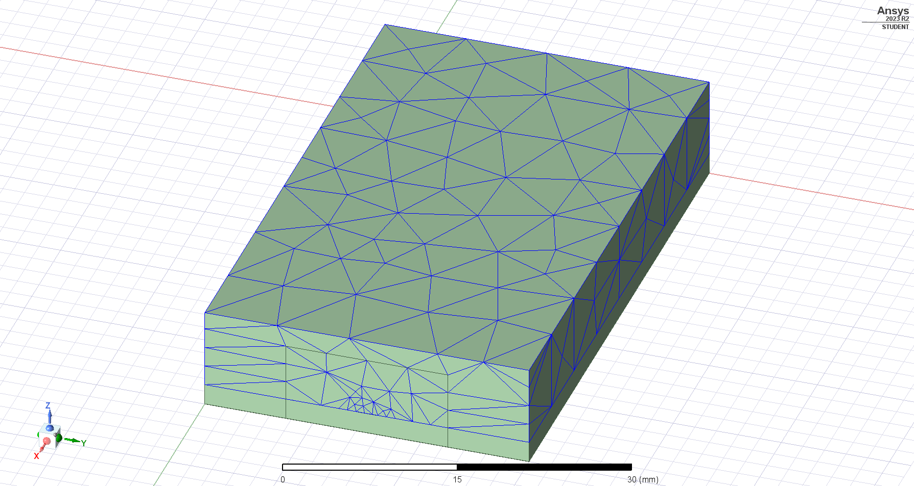

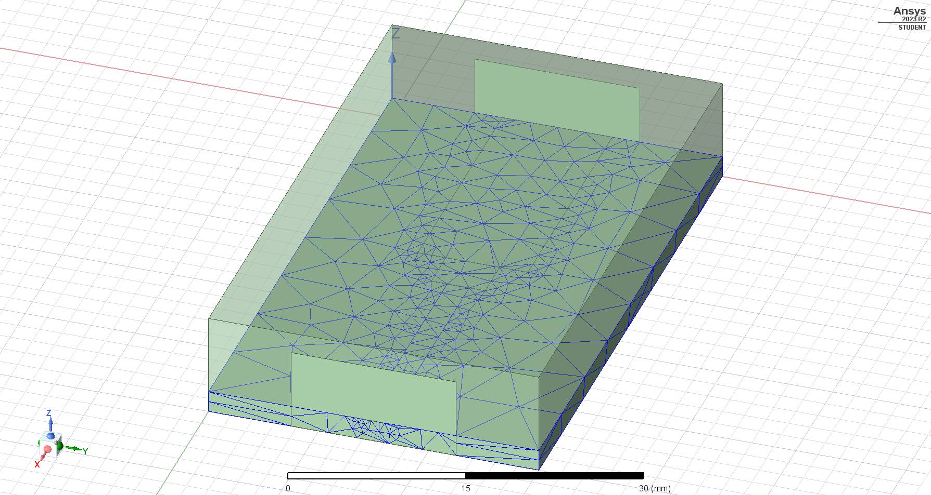

# Single-Stub Matching Network

1. (5 pts) Plot the S-parameters for the structure without the single stub matching.

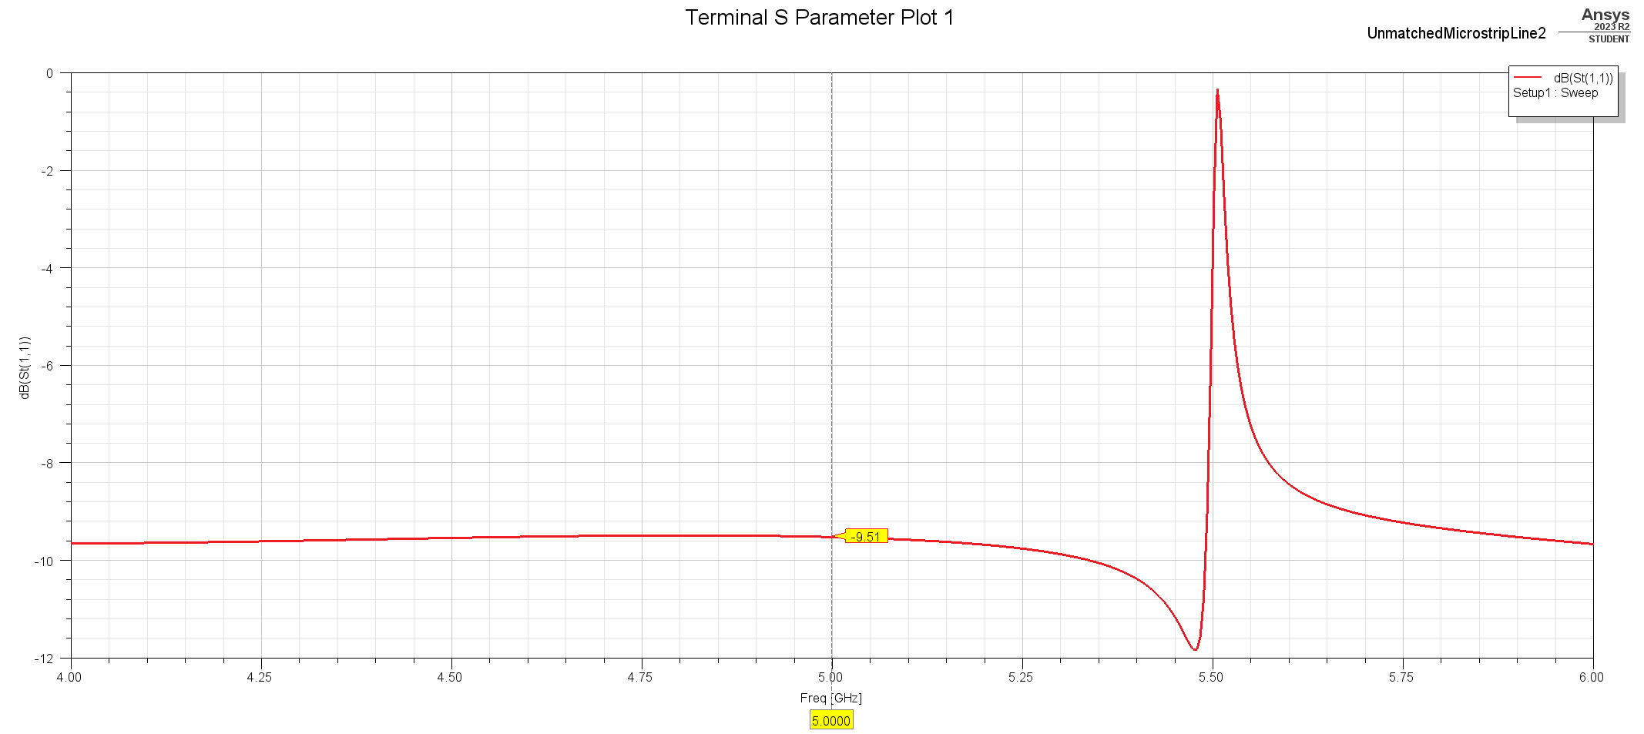

1. (20 pts) Show all your design steps and details on the Smith Chart. For your final design, what is the distance from the impedance mismatch to the nearest edge of the stub? What is the length of the stub? Show a screen capture of your final design.

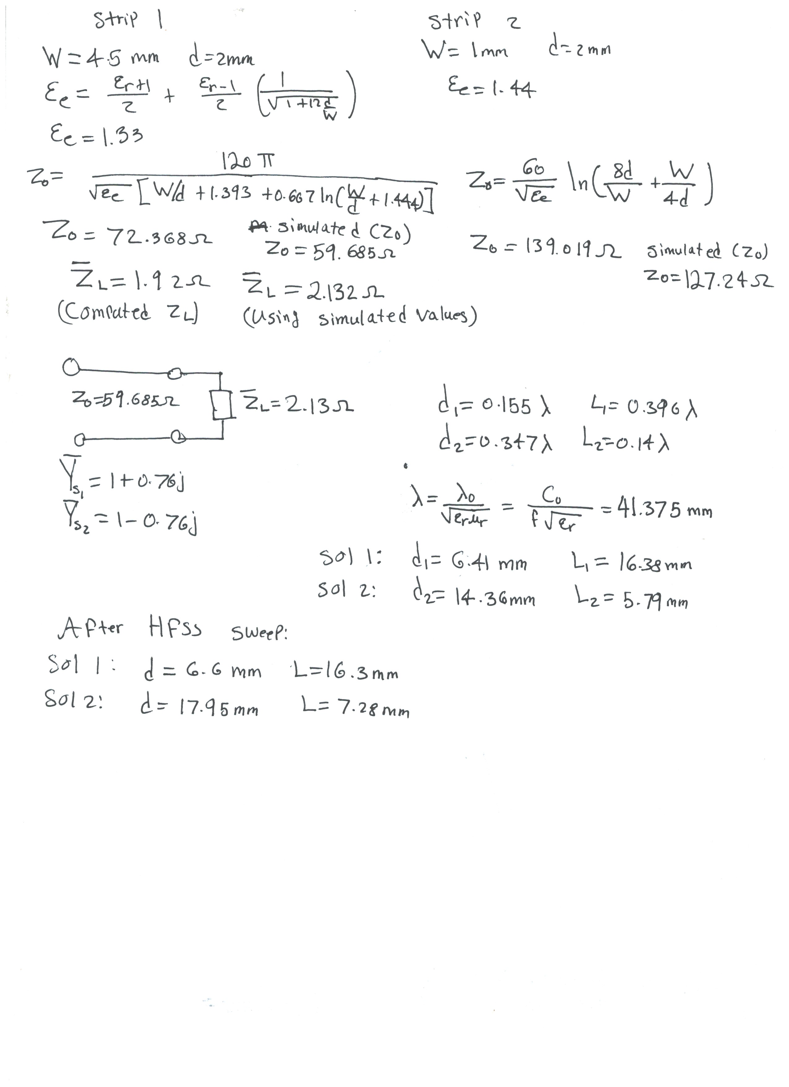

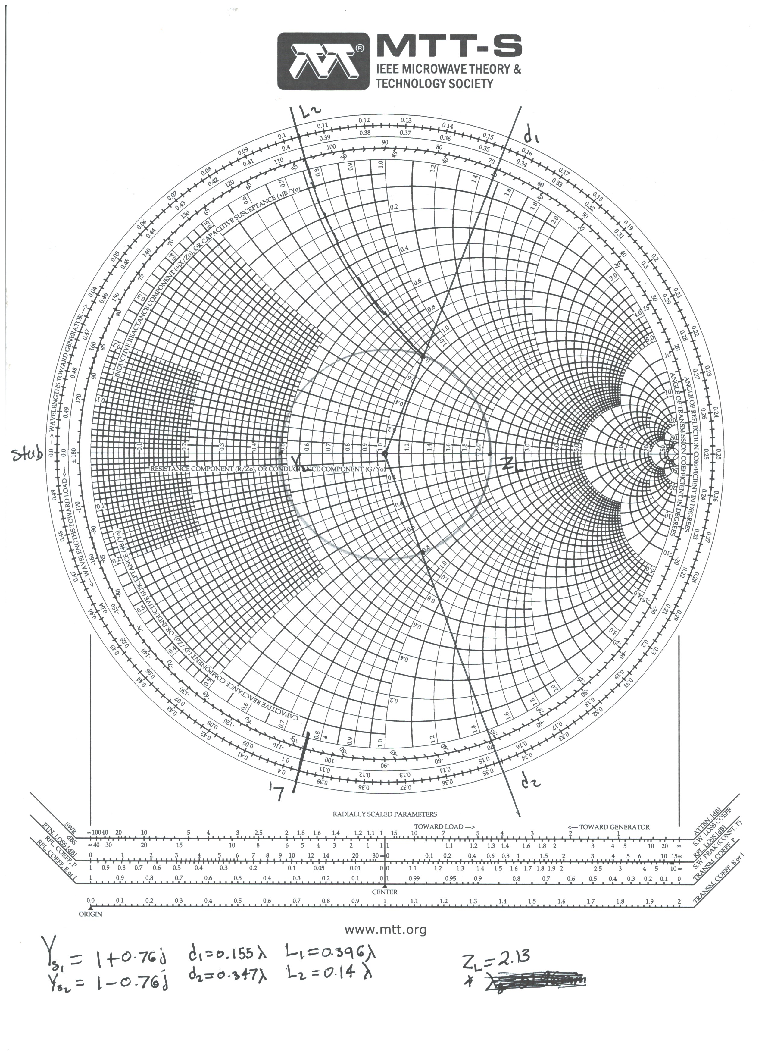

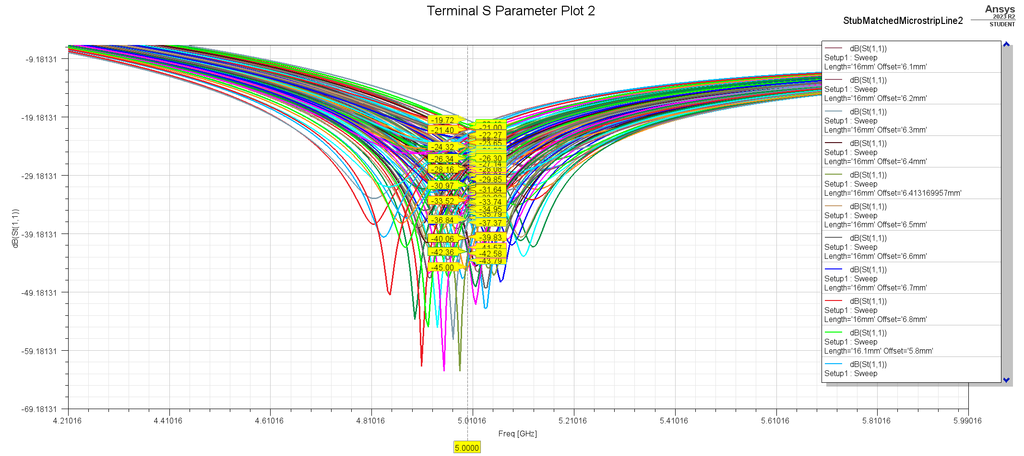

HFSS Sweep for Solution 1

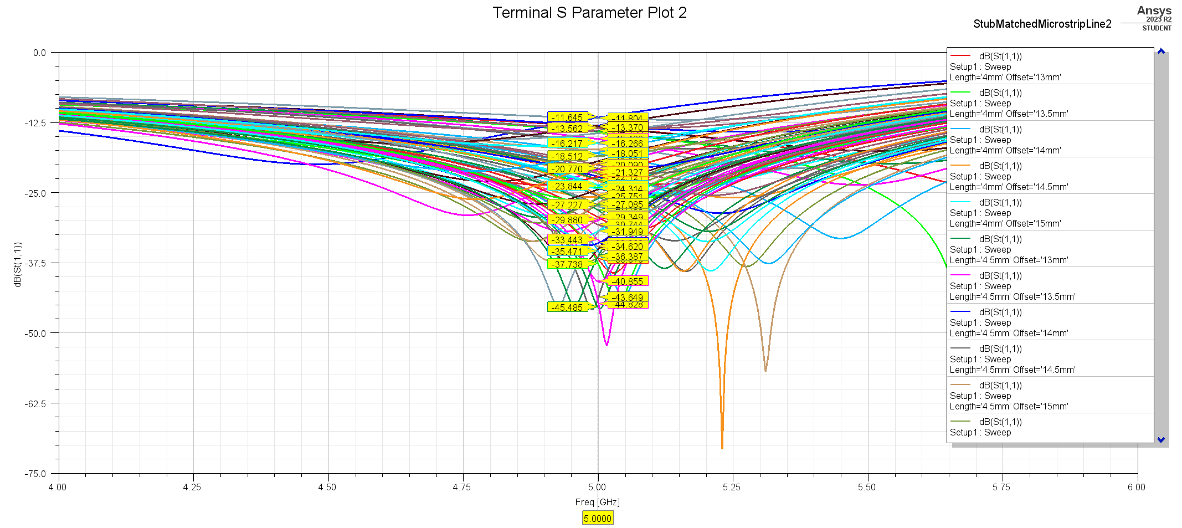

HFSS Sweep for Solution 2

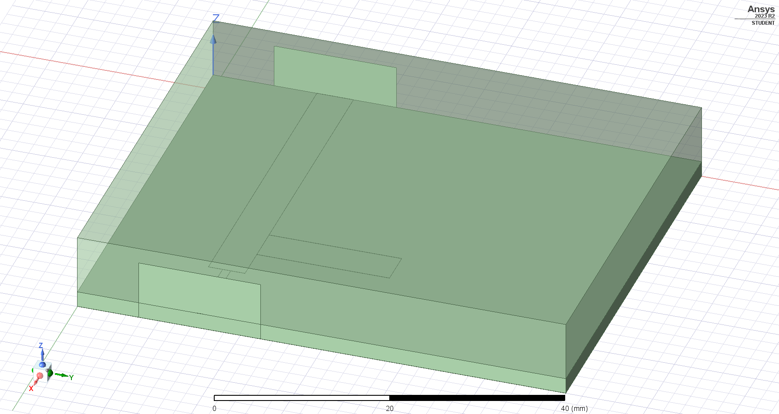

For the final design (solution 1) the distance to the nearest edge of the stub is 4.35mm and the length of the stub is 16.3mm. For the first solution the sweep was performed with radiation boundary condition.

1. (10 pts) Plot the S-parameters for the structure with the single-stub matching network.

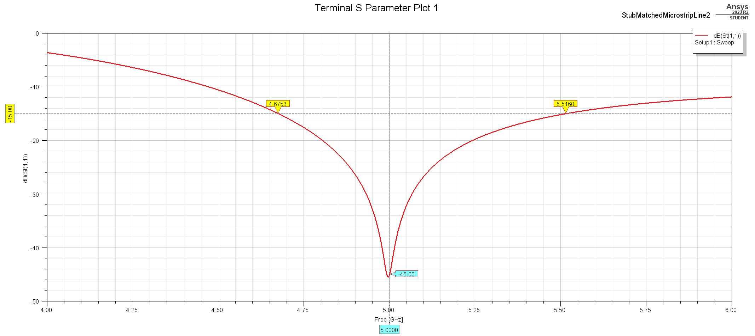

S11 Plot for Solution 1

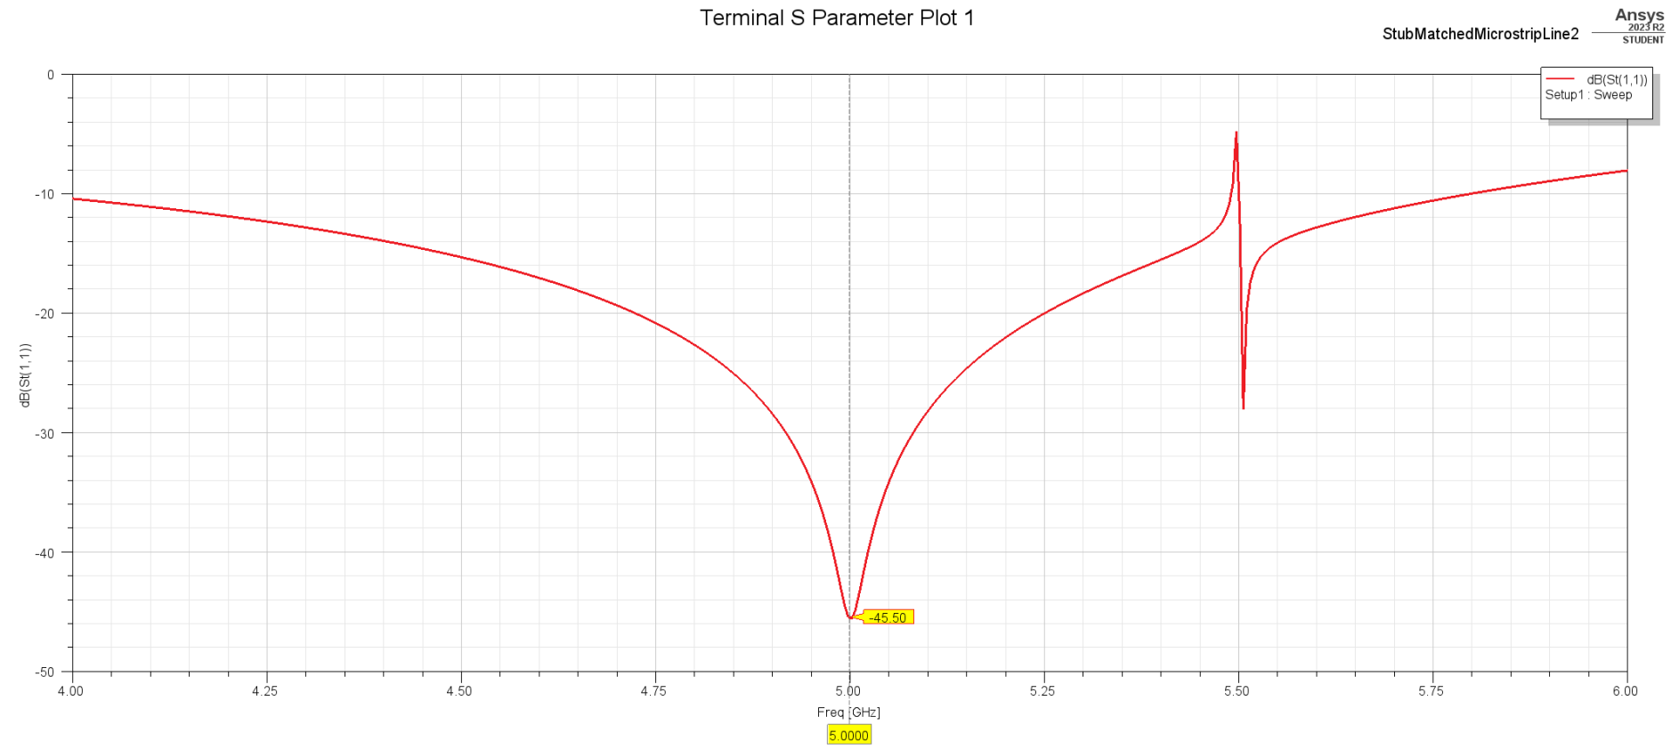

S11 Plot for Solution 2

1. (10 pts) Does the best matching occur at 5 GHz? If not, what is the reason?

The best matching occurs at 5 GHz; however, this was after performing multiple variable sweeps in HFSS. The original computed values did not match at 5 GHz (it was around 4.8 GHz) this was mostly due to the error in the microstrip line equations from the Pozar’s book.

1. (5 pts) Does the single stub match work in the reverse direction?

Yes, stub matching works in the reverse direction.